Azure Fundamentals

We consume many utilities like, water, electricity etc. in our daily life. We don’t care about the infrastructure required for storage, production and distribution for these utilities. We pay the bill for what we consume. So, we rent these services and pay per use.

We use broadband services from various providers. That is also an example of renting service and paying for what we use. Billing can be setup for monthly usage or a fixed price for type of service we use.

When we switch on the light switch, we expect it to light up the connected bulb. We don't care about how electricity is getting generated or transmitted to our premises. It might be generated using hydro powered turbine, windmills or solar panels which are attached to the grids. We just care that it gives you desired voltage and amperes required for the equipment. We pay the bill for what we use.

It is nice to have such benefits available for software professionals. So that we can get rid of day to hassle of maintaining hardware and software infrastructure and we could concentrate on more important work of developing and delivering software quickly and easily. This management is an obstacle in delivering software to user.

# **What is cloud computing**

Cloud computing is, renting and using the computing services like storage spaces of CPU powers virtually on someone else’s computer. We pay only for what we use. These type of service providers are called Cloud Service providers. These services and infrastructures are deployed in the cloud service provider’s data centres and can be located many places in the wold. We can use it from anywhere in the world. Cloud Service providers are responsible for hardware, infrastructure and other software required to provide the services and for there maintenance.

They provide below type of services:

1. **Compute Power:** Such as Windows and Linux servers, Web applications and container services and serverless computing used for computing and processing various tasks.
2. **Storage:** such as Databases for storing structured and unstructured data, file storage systems etc.
3. **Networking:** Such as secure connection between cloud provider’s data centre and our premises.
4. **Analytics:** Such as visualizing and reporting telemetry and performance data.

# **Cloud Service Model**

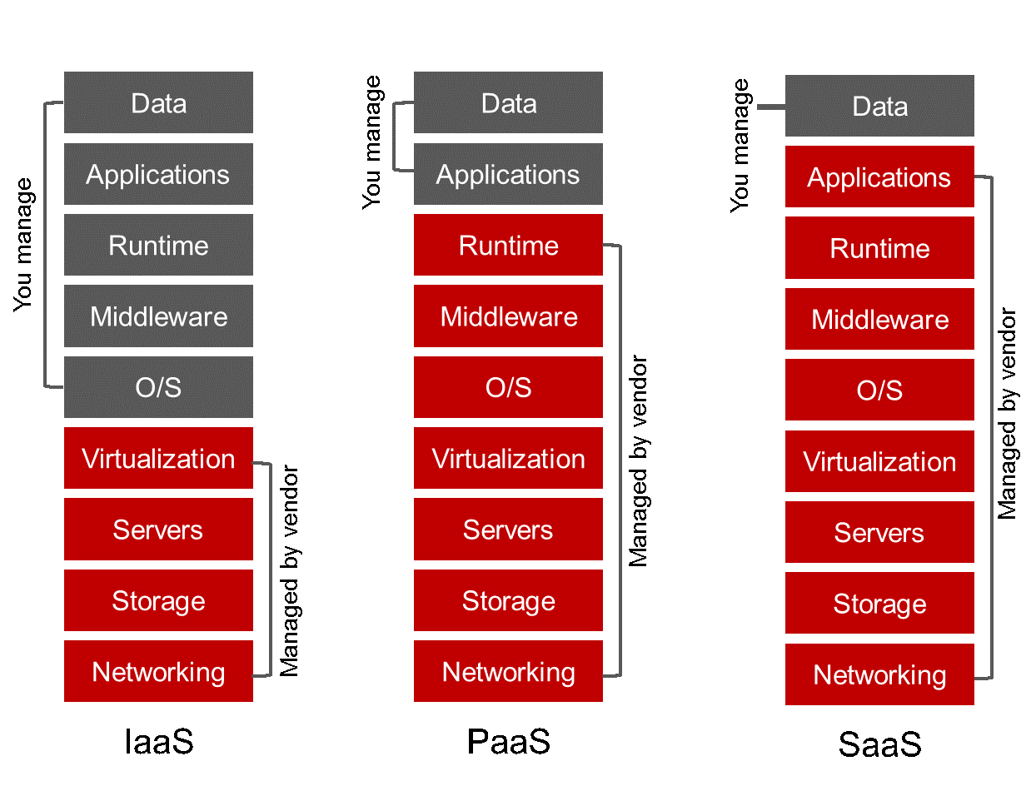

Figure-1A: Depicts the stack covered by each type of service model.

These services are categorized in 3 major categories:

## IaaS :

Infrastructure as a Service like Infrastructure, Networks, Storage Disks, Virtual machine etc.

Service providers provide infrastructure only. We are responsible for installing other software like OS, patching and maintenance of virtual machines and servers. Service provider is only responsible for hardware.

We have to buy individual software licences if you want to install any software like MS Office, or Sql Server, Antivirus etc.

## PaaS:

Platform as a Service: Provides infrastructure and platform like app service, Web Server, Container service

Service provider will provide Infrastructure + Platform like managed instance of Web app, Container Service. We have to deploy your own code. Function app etc. We pay only what we use. There could be a fixed fee + data transaction cost is applied.

PaaS is mainly used by application developer to deploy the software to be used by end users.

## SaaS:

Software as a Service: Cloud service provider manages everything, infrastructure, platform and software. User has to pay the charges based on the time, bandwidth, storage space or number of transactions etc. it can be combinations of these things, as billing has been setup for the service. User is only responsible for data like storing documents, photos and other type for files or structured data.

Some examples are Office 365, SQL Server, DBs, Sql Server, Cosmos DB, Azure Storage services.

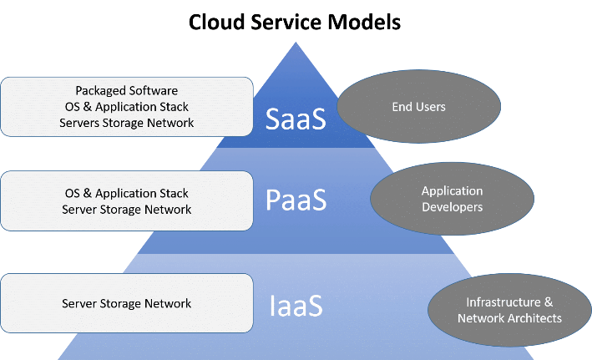

Figure-1B: Cloud service model shows the possible user group of each type of cloud services. Infrastructure engineers mainly work on IaaS layer. Developers deal with the platform layer to deploy and provision services related to deploy the developed software and for CI/CD. End Users consume the software and doesn’t care about how it is maintained or developed. They are just care about their data, documents, file etc.

# **Benefits of Cloud Computing**

## Cost-effective:

Cloud computing provides a **pay-as-you-go** or **consumption-based** pricing model.

This consumption-based model brings with it many benefits, including:

* 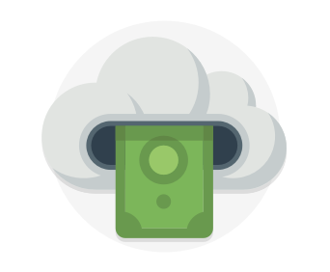No upfront infrastructure costs because no need to purchase infrastructure.
* For some future expansion or for spike, we don’t need to purchase and manage costly infrastructure that may not be used to its fullest for all the time.
* Additional resources can be provisioned as and when required so pay for additional resources only when they are needed
* The ability to stop paying for resources that are no longer needed

## Scalability

In one of my previous company where we used to scrap lots of data every day from various ecommerce websites. When need to add new clients or we need to add more websites to scrap then we need to order more servers. This would take some time to buy the hardware install it in the data centre and install OS and scraping software etc. to use it. So, we needed to plan in advance to do all the work. Finally to get rid of all these hazzles we started using virtual servers in cloud.

Cloud provides ability to add more resources by using few mouse-clicks, we can have one server running in minutes as opposed to months in case of our own data centre.

Cloud avails two types of scaling

* **Vertical Scaling(Scale Up):** What does it mean that We can increase capacity of existing server by adding more cpu cores or cpus, memory, storage space etc. No need to add a machine but use existing with adding more capacity to it.
* **Horizontal Scaling (Scale Out):** Horizontal scaling or scaling out when we add more machine to carry out the work. They function together as a unit. For example, if more incoming request need to process then we can use load balancers to distribute the processing load evenly to all virtual machines.

## Elasticity

* Cloud provides ability to automatically scale up or down capacity of a resource based on the load and utilization. This provides relief from maintaining the resources even when it is not required.

For example, during black Friday period we need more computing power and resources compared to other time of the year. So, we would not be using computing power and resources, required only once or twice a year. During peak season we can allocate more resources to handle high amount of request load. Last year 73 M requests processed during Black Friday and cyber Monday. Overall traffic during that single week was equal to half of the traffic we get in whole year.

Just think how many machine or resource capacity we need to process that amount of traffic.

* We can also have daily or occasional spikes in requests to our servers, for example if client runs a promotion for couple of hours during a day then we get sudden spike of traffic for couple of hours. We can setup rules to scaleup resources if number of requests exceeds by the threshold number. We can also setup rules by cpu percentage. It would automatically add or remove resources using the rules. So, we can keep the cost down.